**Overview of Management**

**What is Management**

Management is a set of principles relating to the functions of planning, organizing, directing and controlling, and the application of these principles in harnessing physical, financial, human and informational resources efficiently and effectively to achieve organizational goals.

**Who are Managers**

* To coordinates and oversees individual getting work done
* To ensure that organizational goals can be accomplished.

**Types of managers**

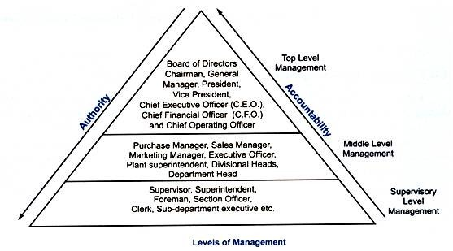

* **Top Managers**
  + Top-level managers are responsible for controlling and overseeing the entire organization.
* **Middle Managers**
  + Middle-level managers are responsible for executing organizational plans which comply with the company's policies. They act as an intermediary between top-level and low-level management.
* **First Line Managers** 
  + First-line managers are the entry level of management, the individuals “on the line” and in the closest contact with the workers. They are directly responsible for making sure that organizational objectives and plans are implemented effectively.
* **Non Managerial** 
  + This are normal employees that will report to the First line Managers and does the work that is assigned by the manager.

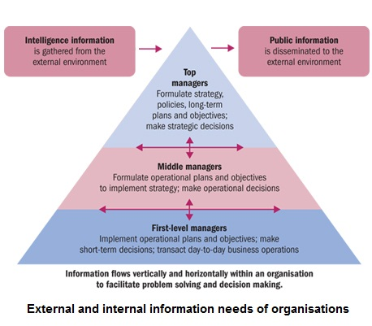

**Efficiency vs Effectiveness**

Efficiency – focus on the maximizing and utilizing of available resources to gain the best and to maximize productivity within the company.

Effectiveness – getting the job done and meeting the intended goals and targets prescribed by the organization.

**What Do Managers Do**

Planning

Achieving the goals of the organization

Organizing

Leading

Controlling

**Planning**

Planning is the function of management that involves setting objectives and determining a course of action for achieving those objectives. Planning requires that managers be aware of environmental conditions facing their organization and forecast future conditions. It also requires that managers be good decision makers.

**Types of planning.**

* **Strategic planning** involves analyzing competitive opportunities and threats, as well as the strengths and weaknesses of the organization, and then determining how to position the organization to compete effectively in their environment. Strategic planning has a long time frame, often three years or more. Strategic planning generally includes the entire organization and includes formulation of objectives. Strategic planning is often based on the organization’s mission, which is its fundamental reason for existence. An organization’s top management most often conducts strategic planning.
* **Tactical planning** is intermediate-range (one to three years) planning that is designed to develop relatively concrete and specific means to implement the strategic plan. Middle-level managers often engage in tactical planning.
* **Operational planning** generally assumes the existence of organization-wide or subunit goals and objectives and specifies ways to achieve them. Operational planning is short-range (less than a year) planning that is designed to develop specific action steps that support the strategic and tactical plans.

**Organizing**

Organizing is the function of management that involves developing an organizational structure and allocating human resources to ensure the accomplishment of objectives. The structure of the organization is the framework within which effort is coordinated. The structure is usually represented by an organization chart, which provides a graphic representation of the chain of command within an organization.

**Leading**

Leading involves the social and informal sources of influence that you use to inspire action taken by others. If managers are effective leaders, their subordinates will be enthusiastic about exerting effort to attain organizational objectives.

**Controlling**

Controlling involves ensuring that performance does not deviate from standards. Controlling consists of three steps, which include

* establishing performance standards
* comparing actual performance against standards
* taking corrective action when necessary.

Performance standards are often stated in monetary terms such as revenue, costs, or profits but may also be stated in other terms, such as units produced, number of defective products, or levels of quality or customer service. The measurement of performance can be done in several ways, depending on the performance standards, including financial statements, sales reports, production results, customer satisfaction, and formal performance appraisals. Managers at all levels engage in the managerial function of controlling to some degree.

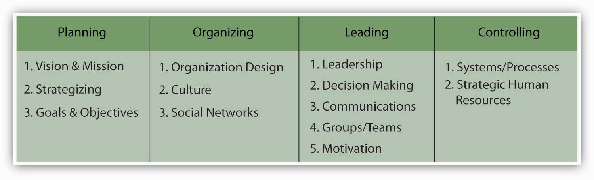

\***Staffing**

* This looks at the overall manpower requirements that needs to be evaluated to see if there is a need to add in more workers, provide training to upgrade the skills and other aspects within the manpower.

**Mintzberg Theory (Roles)**

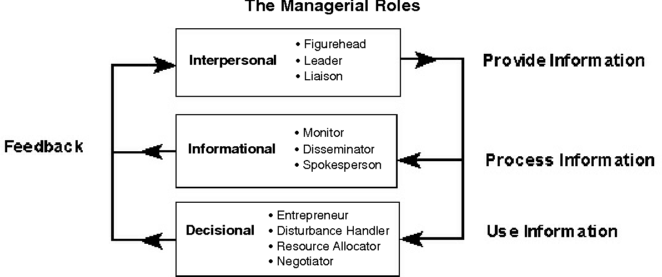

**Interpersonal**

1. *Figurehead.* A figurehead is responsible for social, ceremonial and legal matters. They represent their company in a professional manner.
2. *Leader.* All managers must be leaders, communicating with, inspiring and coaching their team. Workers should be able to look to their manager for support and guidance.
3. *Liaison.* Liaisons are responsible for networking outside and at times within their company and relaying necessary information.

**Informational**

1. *Monitor.* A monitor seeks information within and outside of their company to assess their company's operations and identify issues that need to be approached or changes that need to be made.
2. *Disseminator.* Disseminators should then relay valuable information internally to employees and delegate assignments accordingly.
3. *Spokesperson.* Managers should also relay information externally, acting as a spokesperson for their brand.

**Decisional**

1. *Entrepreneur.* Acting as an entrepreneur, managers should inspire change and innovation. They should also create and implement new ideas.
2. *Disturbance-handler.* Any external or internal issues or roadblocks should be handled by managers.
3. *Resource-allocator.* Managers must allocate and oversee various resources, from funding to equipment.
4. *Negotiator.* The negotiator is responsible for participating and directing negotiations within their organization.

**Skills required by a manager**

**Conceptual Skills**

* These involve the skills managers present in terms of the knowledge and ability for abstract thinking and formulating ideas.
* The manager is able to see an entire concept, analyze and diagnose a problem, and find creative solutions.
* This helps the manager to effectively predict hurdles their department or the business as a whole may face.

**Human Skills**

* Human skills deal with communication and managing interactions among people. Though important and necessary, they represent just one set of skills managers need. Technical and conceptual skills are also necessary.

**Technical Skills**

* Technical skills involve skills that give the managers the ability and the knowledge to use a variety of techniques to achieve their objectives.
* These skills not only involve operating machines and software, production tools, and pieces of equipment but also the skills needed to boost sales, design different types of products and services, and market the services and the products.

**Level of importance where these skills are required**

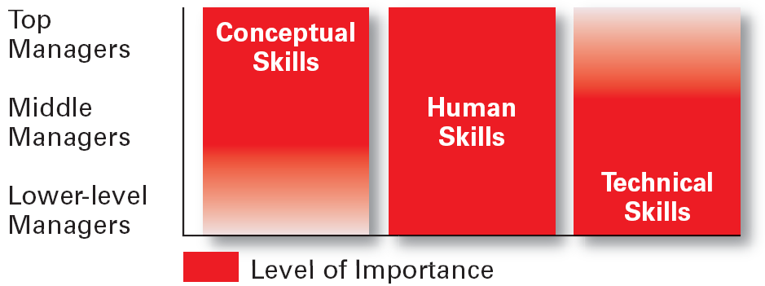

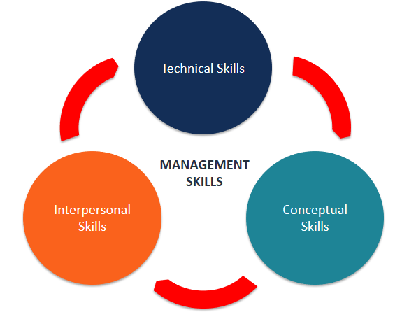

How these interconnect to each other within the management skills requirement.

**Examples of Management Skills**

1. Planning

2. Communication

3. Decision-making

4. Delegation

5. Problem-solving

6. Motivating